<https://youtu.be/rQ9QJRDGWaU>

Grey Paper

HTML

1. Creates a label with a number input button which get tied together with JavaScript.

1. Creates a nav bar that has links take you to other pages of the website and other parts of the page.

1. Attaches images and puts a label on them.

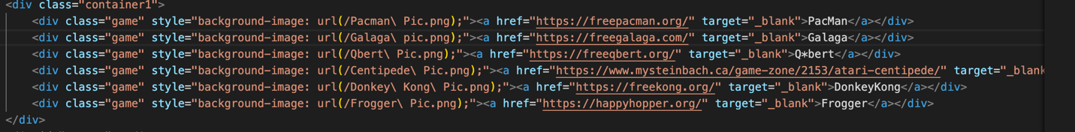

1. Creates a table and puts my contact info into it.

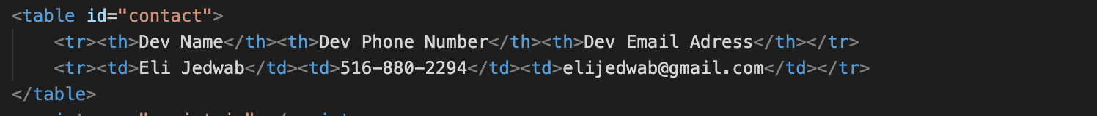

CSS

1. Changes link color, gets rid of the underline, sets its size, and makes it change colors when hovering on it.

1. Creates a rotating animation.

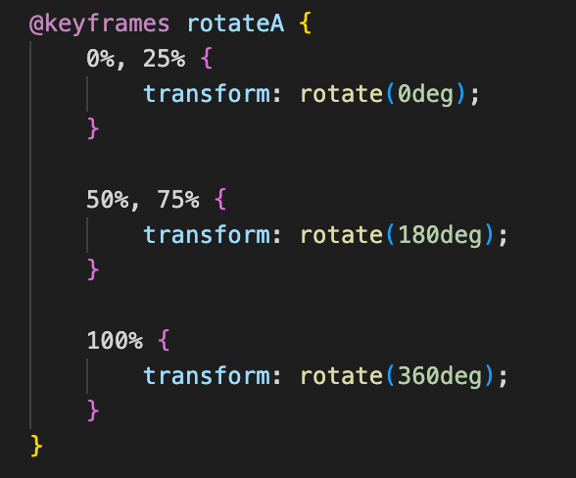

1. Makes anything with the id of toast fixed to the bottom right of the screen and lined up in a column.

1. Sets the size and padding of the input button, sets the color and gets rid of the border. Gets rid of the outline when focused.

JavaScript

1. Makes a function that adds length to strings at certain speeds making it look like its being typed.

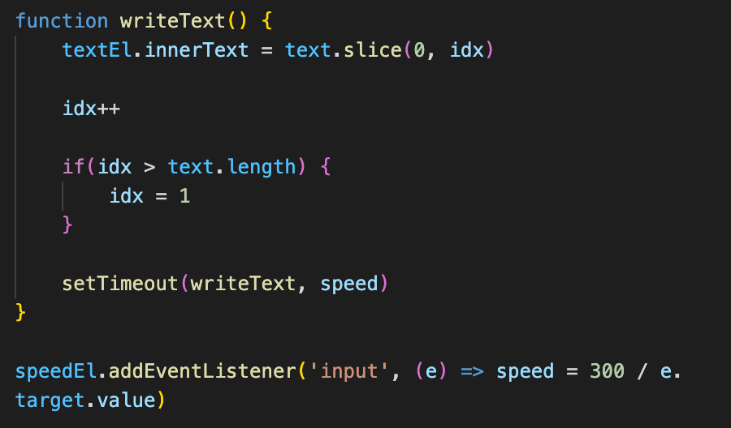

1. Creates a function that moves images over by 500px after a certain amount of time.

